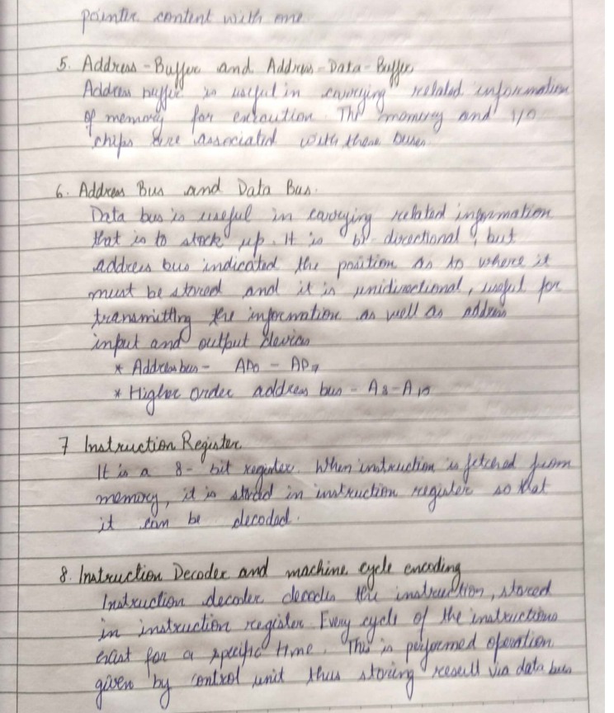

{{r map8 }}

{{r map10 }}

{{r map9 }}

{{r map7 }}

{{r map6 }}

{{r map5 }}

{{r map4 }}

{{r batchid1 }}



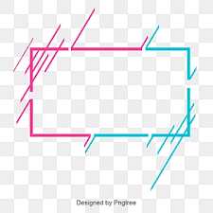

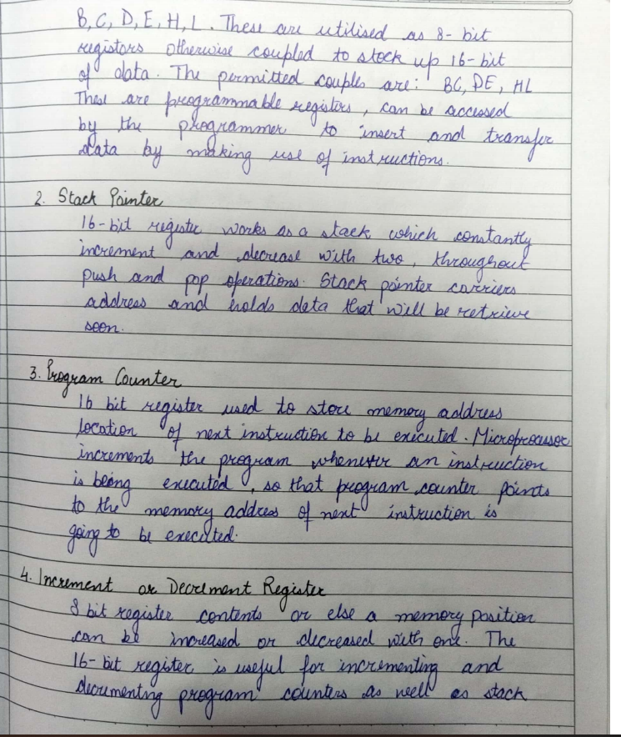

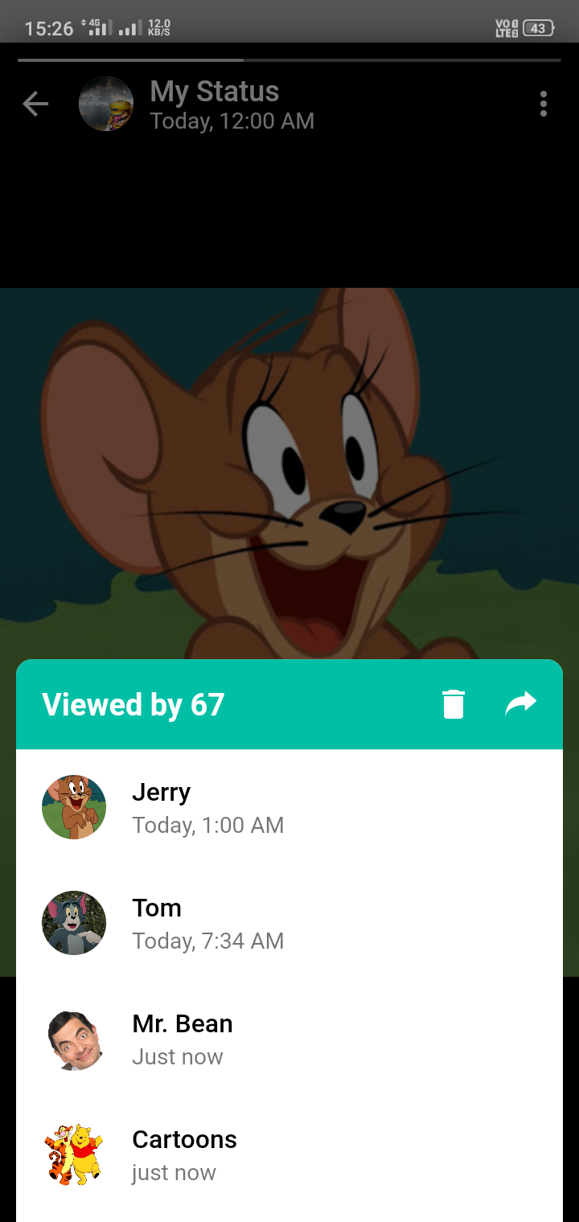

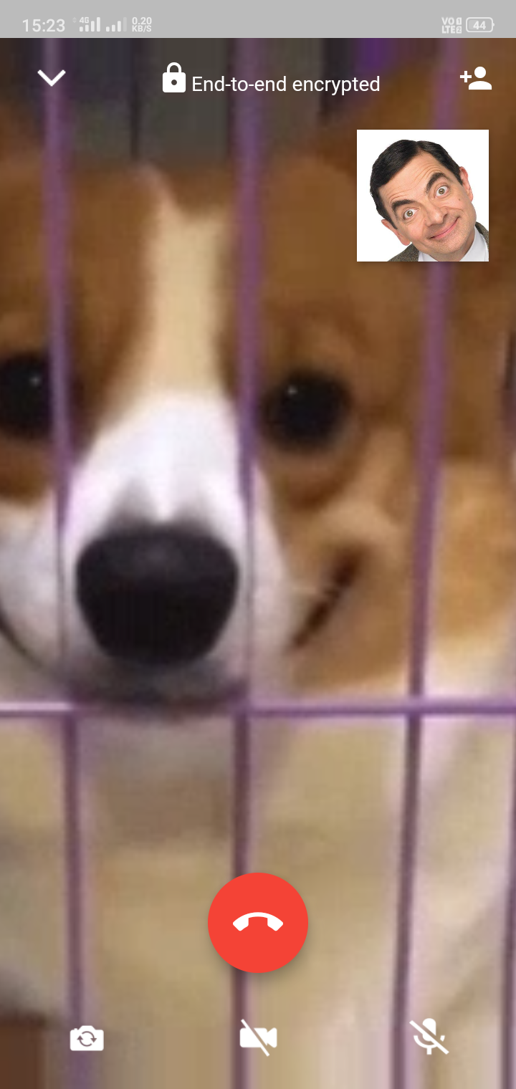

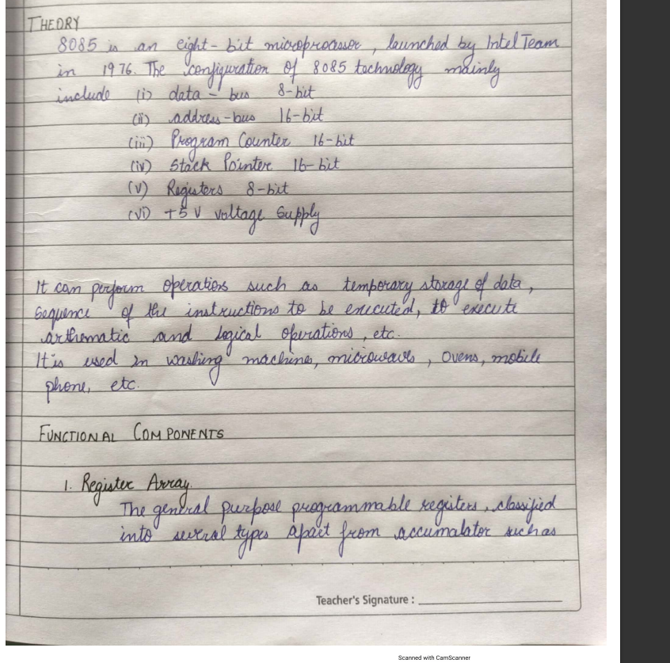

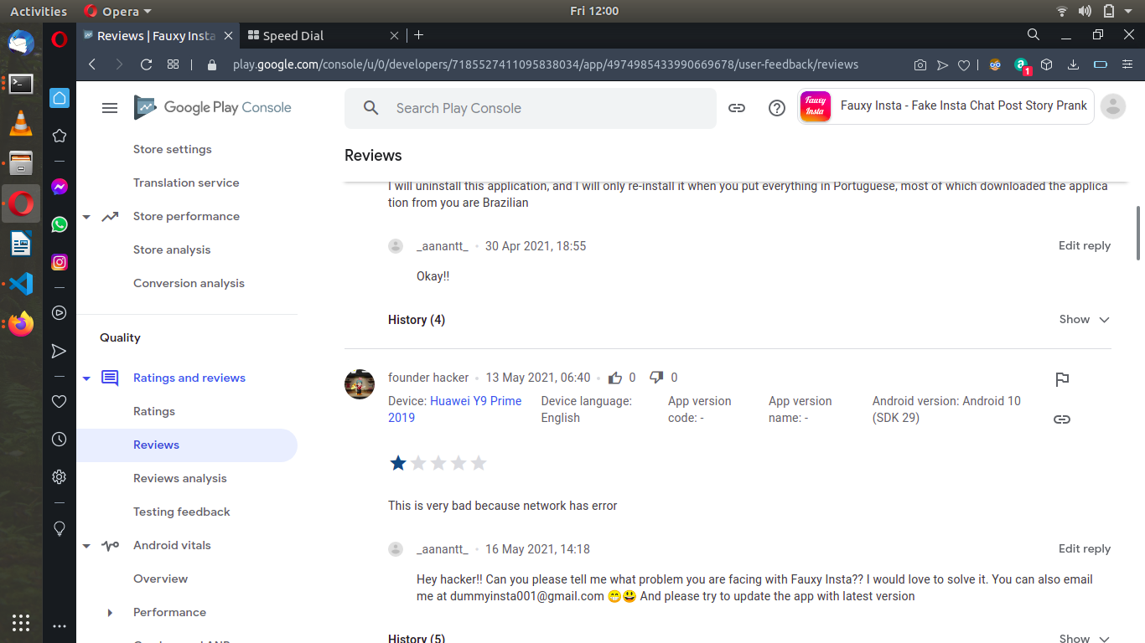



{{r map3 }}



















{{r batchid3 }}

{{r map2 }}

{{r map1 }}

{{r address10 }}

{{r address9 }}

{{r address8 }}

{{r address7 }}

{{r address6 }}

{{r address5 }}

{{r address4 }}

{{r address3 }}

{{r address2 }}

{{r batchid10 }}

{{r batchid2 }}

{{r batchid4 }}

{{r batchid5 }}

{{r batchid6 }}

{{r batchid8 }}

{{r batchid9 }}

{{r batchid7 }}

{{r address1 }}